Understanding the Potential for Collective Impact of SPOR in Ontario
January 21st, 2019, Women’s College Hospital
Background
The SPOR enterprise includes a wide range of networks and entities including the Ontario SPOR Support Unit (OSSU), the Primary and Integrated Care Network (BeACCoN), the Chronic Disease Networks and the Evidence Alliance. Since these groups are all trying to promote patient oriented research in different populations and sectors they are best evaluated through the lens of collective impact. The Collective Impact Framework helps maximize the benefit of diverse groups working in related areas by establishing common goals, shared measurement, and alignment of effort.
Hosted by BeACCoN, a workshop was held on January 21st, 2019 at Women’s College Hospital to:
- Understand the collective impact to-date of the SPOR enterprise in Ontario;
- Learn from the successes and challenges; and
- Coordinate next steps for the future.
This meeting aimed to determine how the SPOR Enterprise has enabled improved health outcomes and enhanced health care experience for patients through integration of evidence at all levels of the health care system. It also aimed to examine the collective impact to date of Patient Oriented Research and how we can work together to enable greater collective impact in Ontario.
Common SPOR Evaluation Challenge
Canadian Institutes of Health Research: Evaluation of the Strategy for Patient-Oriented Research Final Report May 17, 2016
- “CIHR should revise the existing SPOR performance measurement strategy to balance administrative/operational outputs with outcomes/impacts.”
- “Indicators should be re-oriented from tracking primarily activity-based or output indicators toward outcomes and impacts; consider applying a “collective impact” lens.”
Meeting Objectives
- To share information and discuss two key aspects of collective impact – common agenda and common performance metrics
- To provide input to both CIHR and MOHLTC on SPOR 2.0 and to help BeACCoN and OSSU with their renewal
See Introduction Slides Here

The SPOR Enterprise in Ontario: Overview, Opportunities and Challenges
Dr. Cathy Whiteside started the day with a discussion of the opportunity for SPOR in Ontario to drive change through a phased approach:
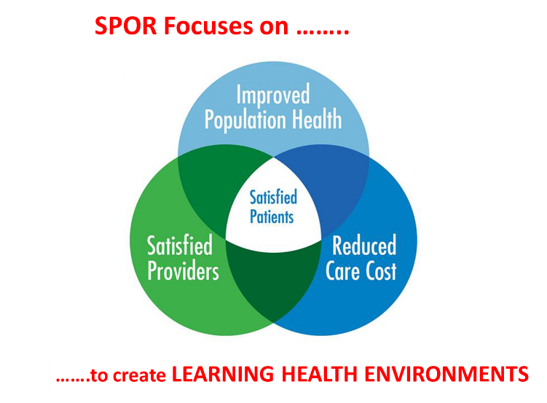
- Establish relations with Patient Partners and create the opportunities for persons (at high risk) to identify their most urgent challenges
- Identify gaps and potential solutions
- Persons (at high risk) identify gaps in health care and community support services
- Health professionals and support service providers identify their needs to fill these gaps
- Researchers search for evidence-based best practices
- Design and conduct intervention
  - Patient Partners, researchers, health care professionals, community organizations and institutions work together to co-design real-world interventions and iterative evaluation to provide evidence for solutions
- Design and evaluate scale-up and spread
  - Patient Partners, researchers (implementation science), health care professionals (multiple disciplines), health system and policy decision-makers work together to design feasible, timely, cost-effective evaluations of scale-up and spread
Dr. Whiteside also highlighted the key SPOR success factors and challenges, the:
- Collaborative and Consistent Engagement of:
  - Patient Partners (including caregivers)
  - Health professionals and communities of practice
  - Health system and policy decision-makers
  - Sustained funding from multiple stakeholders
- ……. with SPOR investigators
Finally, the SPOR opportunity in Ontario was summarized as all the SPOR elements and stakeholders working together:
  - SPOR SUPPORT Unit - Infrastructure and support
  - SPOR Networks, iCTs, Evidence Alliance, Data Platform
  - Health system and policy decision-makers
  - Government, agencies and health care institutions
  - Sponsoring stakeholders (CIHR, NGOs, private sector)
to achieve collective impact.

See the SPOR in Ontario Slides Here

Collective Impact
Dr. Onil Bhattacharyya drew on the work of FSG and the Tamarack Institute to provide an overview of how the concept of Collective Impact can be applied to SPOR, moving from isolated, siloed initiatives to working towards the same goal with the same set of metrics. He first described the status quo, isolated impact:
- Funders select individual grantees
- Groups work separately
- Evaluate to isolate a particular group’s impact
- Make large scale change by scaling organizations or projects
- Communities and government loosely or disconnected.

And then went on to illustrate the transition towards collective impact:
- Funders understand that social problems – and solutions – arise from multiple interacting factors
- Cross-sector alignment with government and community sectors as partners
- Organizations actively coordinate their actions and share lessons learned
- All work toward the same goal and measure the same things

Dr. Bhattacharyya then outlined the key elements of a Collective Impact approach:
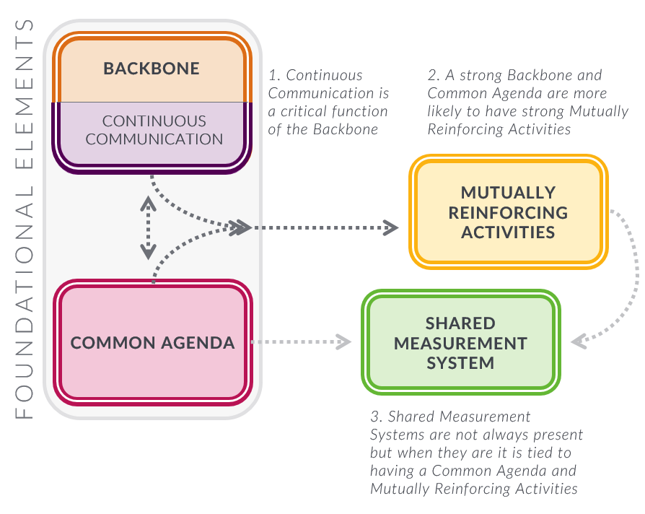
1. Common agenda
2. Shared Measurement System
3. Mutually reinforcing activities
4. Continuous Communication
5. Backbone Organization

The shared measurement system was also highlighted as key for SPOR, with metrics covering multiple aspects, including:
- Process (# of presentations, partnerships),
- Progress (programs, # of new initiatives)
- Policy (rules and regulations, funding and investments)
Population (# of patients/clients with improved outcomes, experiences)

See the Collective Impact Framework Slides Here

Reports and Discussion on Agenda and Success Stories of Each SPOR Element in Ontario
Each SPOR initiative provided an overview of their agenda and a SPOR Success Story, highlighting how their SPOR element has changed outcomes and the system in Ontario. We heard from:
- ACCESS Open Minds
- BeACCoN
- CanSOLVE-CKD
- CHILD-BRIGHT
- Chronic Pain Network
- Diabetes Action Canada
- SPOR Evidence Alliance
- IMAGINE
- OSSU

See Network Agenda and Success Slides Here

The presentations were followed by a group discussion on the common agenda across SPOR initiatives:
Changing the culture
There was recognition that SPOR has changed the way we do research in Ontario – by putting patients and caregivers at the centre, and by demonstrating the value of involving patients and communities in how we set priorities, conduct research, and scale and spread innovations.
SPOR has also changed how we work together – emphasizing the power of collaboration across researchers, but also including policymakers, providers, patients rather than championing isolated achievements.
The group also discussed that we can go further, in engaging with harder to reach communities, indigenous, sex and gender, as well as on the cross-cutting themes of early intervention and social determinants of health.
The next step for the group was to address how we can now measure this culture change, what is the impact and what are the important outcomes.
Research Evaluation and SPOR in Ontario
Dr. Eddy Nason from the OSSU then presented on evaluation and SPOR in Ontario. Dr. Nason outlined the current issues in evaluating the impact of research: from the shorter to longer term. The conversation on impact has switched since the 5-year SPOR evaluation to one that focuses on:
- Collective impact
- Stronger focus on ultimate outcomes
- Acceptance of the challenge of metric-based approaches
- Attempt to clarify evaluation vs. performance measurement
The dual concepts of Narrative vs. Metrics was also introduced as a way to more holistically capture the impact of SPOR in Ontario.
Narratives:
- Impact narratives can effectively communicate complex information
- Impact narratives require organization and thought
- There are processes to go through to build impact narratives
- There are templates and guidance available to you
- Analyzing impact narrative analysis to assess aggregate effects can be tough but worthwhile

Metrics
- Impact metrics provide easily comparable year-on-year data
- Metrics can be subject to both statistical analysis and targets
- Common metrics can be easily compared across evaluations
- Metrics tend to be reductive and miss impacts
- Metrics are subject to misinterpretation and gaming
- Metrics drive behaviour (often in unexpected ways)

The key takeaway was that although the need for metrics was recognized, it should be combined with narratives to provide a more complete picture of the impact of SPOR in Ontario.
See Research Evaluation Slides Here
Reports and Discussion on Evaluation Plans and Metrics of each SPOR Element in Ontario
Mirroring the earlier session, each SPOR element then presented their evaluation plans and metrics, which was followed up by a group discussion.
See Network Evaluation Slides Here
Please See Full Slides from the Day Here

Common themes were found:
Capturing impact
There was agreement in the room around how difficult it is to capture impact in this space – such as how to evaluate the ways in which patient engagement affected the research conducted and the results of the work. There was also discussion about how economic value and ROI can be demonstrated – i.e., How do we show the return on the investment in SPOR to patients in Ontario – for example, telling the story of how the research led to new practices that changed outcomes for patients. There was agreement that SPOR has changed the way that research is conducted, but the challenge is demonstrating the improvements that have come as a result of this culture shift. There was agreement that metrics are not enough, and should be complemented by narratives, preferably in the form of an “evidence-informed anecdote”.
The impact of networks
It is relatively simple to quantify the depth and breadth of engagement, however it is more difficult to understand the power of the network. There is good evidence that networks help translate research into impact, but SPOR entities face the common challenge of how we demonstrate this impact. There was also recognition that the evaluation and way forward for SPOR needed to take into account the changing political and economic landscape in Ontario, and how any messaging should be amenable to an “Elevator pitch” or the need to provide a personal perspective or vignette, which is as important as the metrics behind it.
Summary
The session provided a unique opportunity for all the SPOR Networks in Ontario to share their vision, mission and agenda. A key element of the common agenda was that all the Networks shared a strong and consistent commitment to patient-oriented research in which there is active engagement of patients and caregivers in all phases of network activity. For many, this represented a fundamental change in the culture of the research enterprise and resulted in a research that is focused on issues and challenges that are priorities for patients and caregivers and research that involves patients and caregivers.
Another common element was that each Network had developed new and creative forms of collaboration across research groups. The network philosophy and the active engagement researchers across multiple institutions and provinces shows the emergence of a common agenda.
The discussion highlighted the opportunity to extend the success in collaboration within networks to collaboration across networks.
The session allowed the groups to share their evaluation strategies and to discuss them in the context of collective impact. It is clear that all the SPOR Networks have developed strategies around evaluating impact that are guided by the criteria set by CIHR. The presentations highlighted that both metrics and narratives are key components of the SPOR evaluation.
The discussion focused on the idea of using collective impact as a common overlay that could build on the existing evaluation work within each Network. It was pointed out that narratives built on how the research from the networks could change the care for particular types of patients and caregivers has an important role in communicating impact to both the public and to policymakers. At the same time there is a need to build a business case for impact that looks at return on investment and that looks at real world impact of the SPOR project outcomes based on both value and cost. The SPOR enterprise is a network of networks and that may require metrics and narratives that may not have been developed by individual networks.
SPOR has changed how we work, who we work with and how we make impact in the system for patients. Our challenge now is to demonstrate the value of the collective impact SPOR for the province, patients and the system at large.
Next steps
The individual Networks are encouraged to build on the connections and ideas that were shared at the session, the materials presented at the meeting and this session summary.
We will follow up with attendees to solicit ideas for further meetings.
We hope the presentations and discussion at the session will inform ongoing efforts to shape the national and provincial discussions on SPOR 2.0 and the renewal efforts for specific elements of the SPOR enterprise in Ontario.

Appendix 1 – List of Attendees
Onil Bhattacharyya – Associate Professor, Department of Family and Community Medicine, University of Toronto; Frigon Blau Chair in Family Medicine Research, Women’s College Hospital
Geoff Anderson – Research Lead, BeACCoN; Professor, Institute of Health Policy, Management and Evaluation, University of Toronto; Adjunct Scientist, Institute for Clinical Evaluative Sciences (ICES); Adjunct Scientist Women’s College Hospital Research Institute
Ivy Wong – Network Director, BeACCoN
Kristen Pitzul – Manager, Data & Analytics, BeACCoN; Funding and Performance Advisor, Ontario Hospital Association
Dara Gordon – Policy Research Coordinator, Institute for Health Systems Solutions and Virtual Care (WIHV), Women’s College Hospital
Deborah VanOosten – Senior Research/Planning Advisor, Research Planning and Management Unit, MOHLTC
Alvin Cheng – Director of Health Analytics and Innovation, Toronto Central LHIN
Cathy Whiteside – Executive Director, Diabetes Action Canada (DAC) – A SPOR Network in Diabetes and its Related Complications
Alies Maybee – Patient Advisor, Patient Advisors Network (PAN)
Annette McKinnon – Patient Advisor, Patient Advisors Network (PAN)
Anne Hayes, Director of Research, Analysis, and Evaluation Branch, MOHLTC
Kimberly Begley – Managing Director, Chronic Pain Network, McMaster University
Jordan Benadiba – Communications Specialist, Women’s College Hospital
Glynnis Burton – Consultant, Health Analytics and Innovation, Toronto Central LHIN
Charles Victor - Senior Director, Strategic Partnerships and External Services, ICES
Seth Chitayat – Director, Health Research Partnerships, Queen’s University
Eden Klein – Associate Manager, Research, Heart and Stroke
Aida Fernandes - Executive Director, IMAGINE SPOR Research Network
Minnie Ho – Director, Data and Analytic Services, ICES
Amy Hsu - Postdoctoral Research Fellow, Ottawa Hospital Research Institute; Postdoctoral Research Fellow, ICES
Sophia Ikura – Executive Director, Population Health Solutions Lab, Sinai Health System; Senior Director of Strategy, Community Engagement and Corporate Affairs, Toronto Central Local Health Integration Network
Jess Chisholm - Director of Operations , ACCESS Open Minds
James Scholey – SPOR CAN-SOLVE CKD
Leah Getchell - Patient Partnerships & Training Lead, SPOR CAN-SOLVE CKD
Robin Mason - Scientific Lead, Women’s Xchange; Scientist, Women’s College Research Institute; Assistant Professor, Dalla Lana School of Public Health, University of Toronto
Kathy McGilton, SPOR Researcher; Senior Scientist,Toronto Rehabilitation Institution, University Health Network; Associate Professor, Lawrence S. Bloomberg Faculty of Nursing; Associate Professor, Graduate Department of Rehabilitation Sciences, University of Toronto
Neil McMullin – Manager, MOHLTC
Meghan McMahon – Project Director, CIHR Institute of Health Services and Policy Research
Payal Agarwal – Innovation fellow, Women’s College Hospital
Conrad Pow – Senior Project Manager, Diabetes Action Canada
Samira Chandani – Patient Advisor, Patient Advisors Network (PAN)
Tracy McQuire – Manager, Research Operations, Diabetes Action Canada, CIHR SPOR Network
Ruta Valaitis – Investigator, Diabetes Action Canada; Associate Professor, School of Nursing at McMaster University
William Hogg - Senior Research Advisor, Department of Family Medicine, University of Ottawa; SPOR PIHCIN
Wasifa Zarin – Research Manager, SPOR Evidence Alliance; St. Michael’s Hospital

Image from: https://ssir.org/articles/entry/does_collective_impact_really_make_an_impact

